# 1.Git-HOL Execution Git Hands-On Lab — Execution Report

## Objective

The objective of this lab was to become familiar with basic Git commands such as git init, git status, git add, git commit, git push, git pull, and to integrate a default editor (Notepad++) with Git.

## Prerequisites

1. Git Bash installed on Windows.

2. Notepad++ installed and available in PATH.

3. A GitHub account to create a remote repository named GitDemo.

## Step-by-step Execution

### Step 1 — Check Git Installation

Command used:

git --version

Expected output:

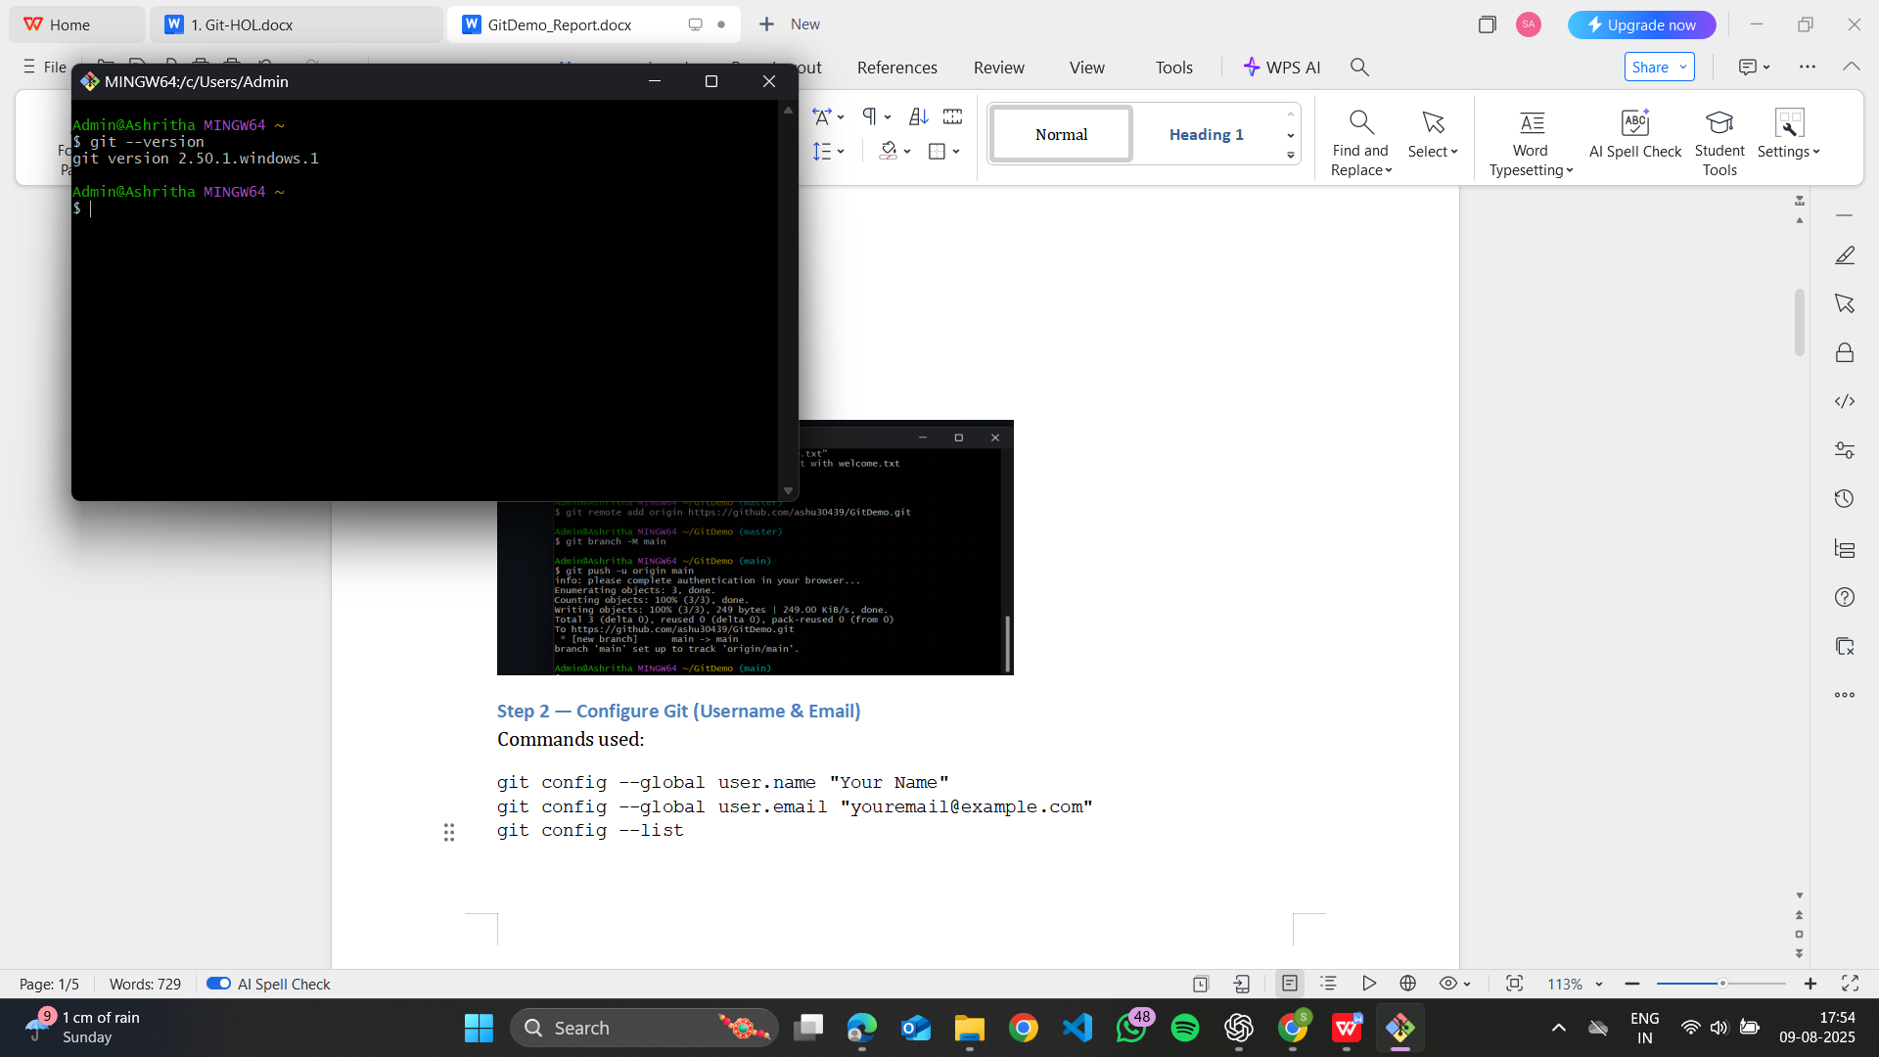

### Step 2 — Configure Git (Username & Email)

Commands used:

git config --global user.name "Ashritha"  
git config --global user.email "ashrithamerugu@gmail.com"  
git config --list

Explanation: This sets your identity for commits.

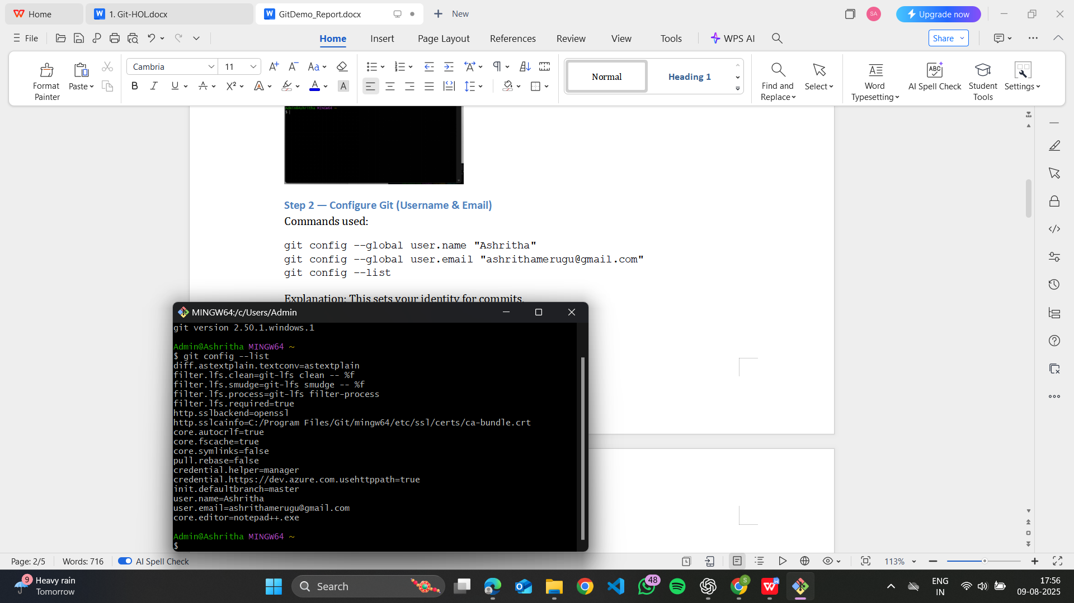

### Step 3 — Set Notepad++ as Git Editor (optional)

If you installed Notepad++ and added it to PATH, configure Git to use it as the default editor.

git config --global core.editor "notepad++.exe"  
git config --global -e

Action taken: Notepad++ opened when running the config edit command. Save and close Notepad++ to return to the Git Bash prompt.

Take a screenshot showing Notepad++ opened via git config -e and the saved configuration.

Screenshot — Notepad++ opened from Git Bash:

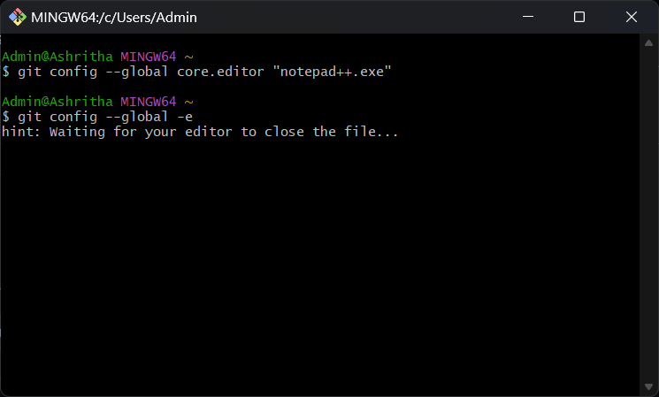

### Step 4 — Create Local Repository

Commands used:

mkdir GitDemo  
cd GitDemo  
git init

Expected output: repository initialized (hidden .git folder created).

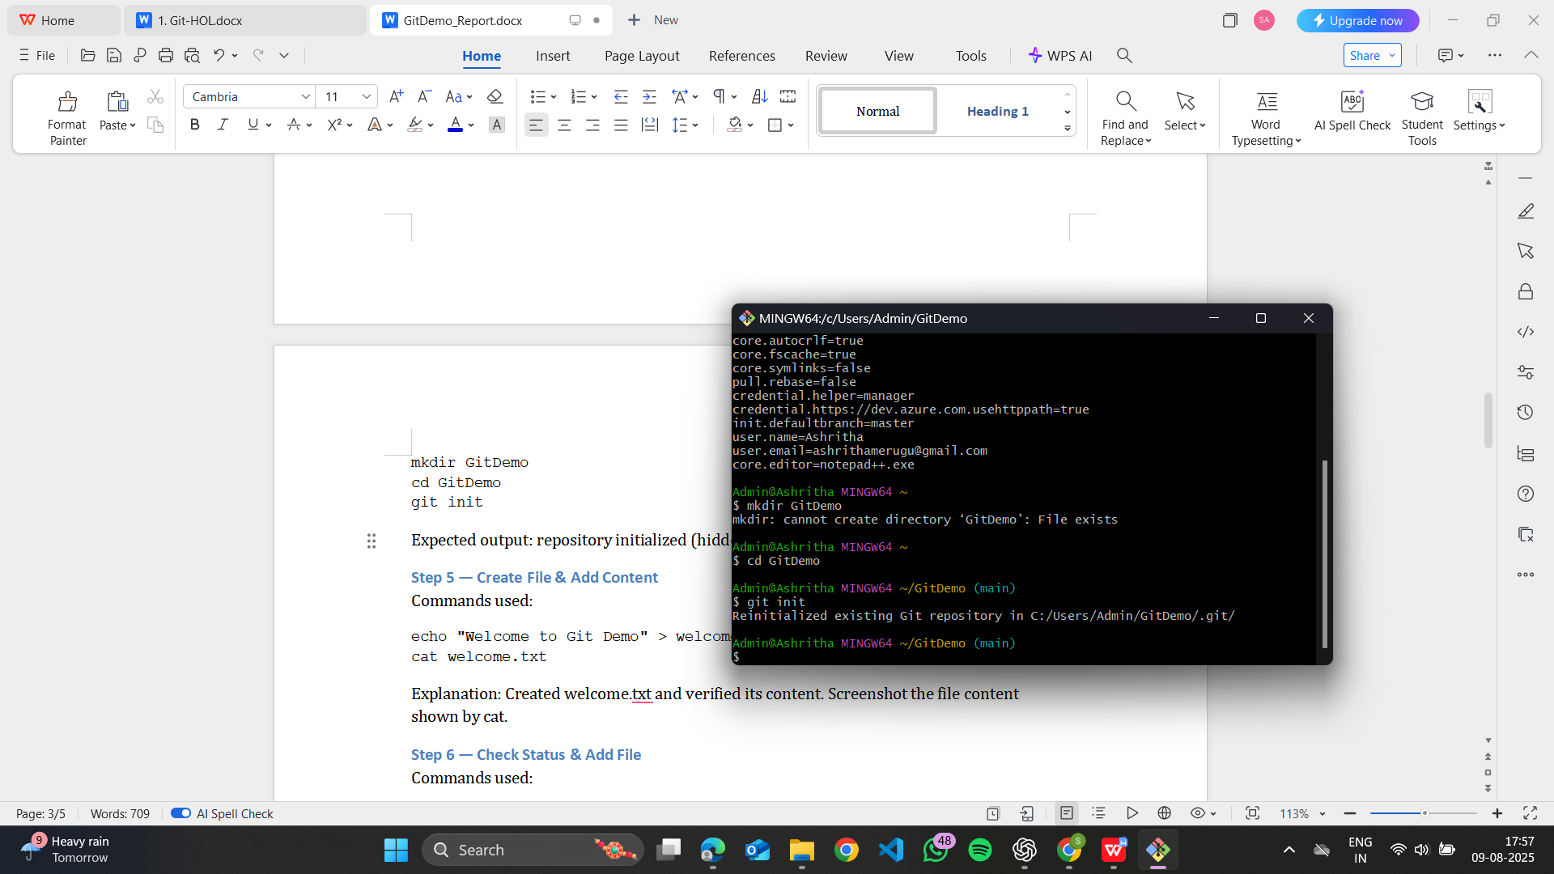

### Step 5 — Create File & Add Content

Commands used:

echo "Welcome to Git Demo" > welcome.txt  
cat welcome.txt

Explanation: Created welcome.txt and verified its content.

### Step 6 — Check Status & Add File

Commands used:

git status  
git add welcome.txt

Note: You may see a warning "LF will be replaced by CRLF" on Windows. This is a line-ending conversion warning and is normal. It does not affect the functionality. Take a screenshot of git status showing welcome.txt as untracked and then after git add.

### Step 7 — Commit File

Command used:

git commit -m "Initial commit with welcome.txt"

Expected output: commit created.

### Step 8 — Create Remote Repository on GitHub

On GitHub website: Create a new repository named "GitDemo". Do NOT add a README in the web UI (so local and remote histories align). Screenshot the newly created empty repository page.

### Step 9 — Link Local Repo to Remote & Push

Commands used (replace YOUR_USERNAME with your GitHub username):

git remote add origin https://github.com/ashu30439/GitDemo.git  
git branch -M main  
git push -u origin main

Expected output: Authentication prompt (if using browser-based auth), then push completes and the branch is set to track origin/main. Take a screenshot of the successful push in Git Bash and of the GitHub repository page showing welcome.txt.

Screenshot — GitHub repository with welcome.txt and Git Bash push output:

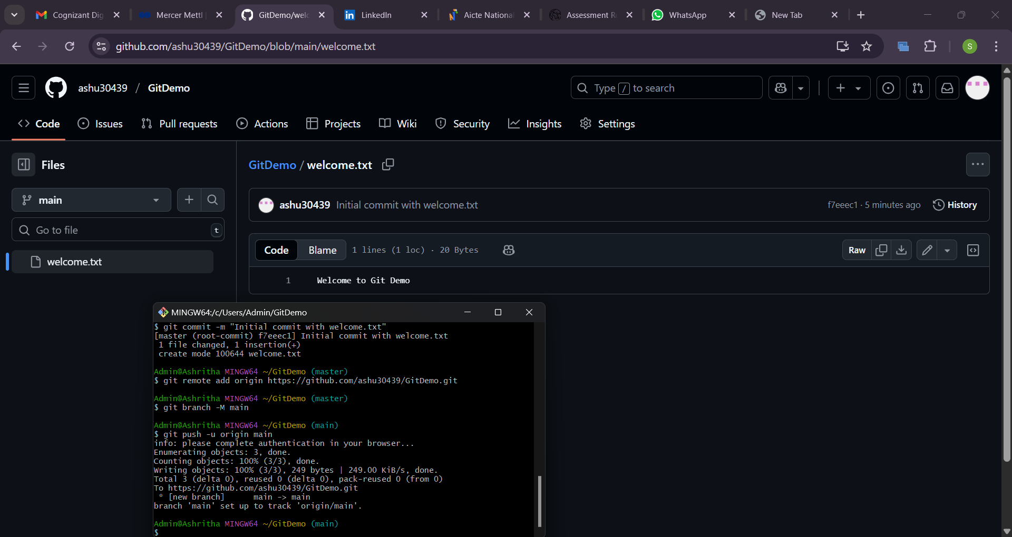

### Step 10 — Verify Remote & (Optional) Pull

Command used:

git pull origin main

This verifies that the remote is accessible and content can be pulled back into the local repository.

## Useful Commands (quick reference)

git status  
git add <file>  
git commit -m "message"  
git remote -v  
git branch -M main  
git push -u origin main  
git pull origin main  
git log --oneline